Chapter 5 Stoichiometry name: class:
考点 A: 实验数据处理 Experimental Data
1. 有效数字 (Significant Figures) 基本规则
Non-zero digits are always significant; leading zeros are not significant; trailing zeros after decimal are significant
In multiplication/division: result has same number of sig figs as the measurement with fewest sig figs
In addition/subtraction: result has same decimal places as the measurement with fewest decimal places
(本章题库暂无考点 A 专项选择题)
考点 B: 质谱、相对质量与摩尔 Mass Spectroscopy & Moles
1. 质谱法 (Mass Spectrometry) 原理与谱图解读
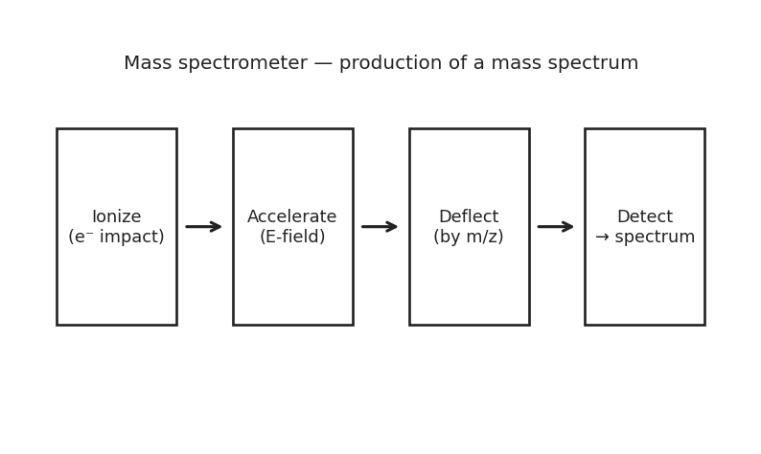
图 C₅-1：质谱仪工作原理流程示意（对应考点 B：质谱法）
Relative atomic mass: weighted average of isotope masses by natural abundance
Avogadro constant N_A = 6.022 × 10²³ mol⁻¹
Molar mass (M): mass per mole, units g/mol
Conversions: mass ↔ moles ↔ particles (molecules, atoms, ions)

1. How many moles of ethane (C₂H₆) are there in 5.3 g of ethane? （ ）
A. Option A⁻¹ mol
B. Option B
C. Option C
D. Option D

2. To two decimal places, what is the molar mass of (NH₄)2SO₄? （ ）
A. Option A⁻¹
B. Option B⁻¹
C. Option C⁻¹
D. Option D⁻¹

3. The mass of one atom of calcium is （ ）
A. Option A
B. Option B⁻²³ g
C. Option C
D. Option D

4. How many atoms of iron are in 1 mole of Fe₂O₃ （ ）
A. Option A
B. Option B
C. Option C
D. Option D

5. How many molecules of propane (C₃H₈) does a 23.0 g sample of propane contain? （ ）
A. Option A⁻²⁵
B. Option B
C. Option C
D. Option D

6. The sample that contains the greatest number of moles is （ ）
A. 1 g of methanal, CH₂O
B. 2 g of carbon dioxide, CO₂
C. Option C
D. Option D

7. How many moles are in 860 atoms of gold? （ ）
A. Option A
B. Option B⁻²¹ mols
C. Option C
D. Option D

8. What is the mass of 8.54 ×10²⁰ particles of Cl₂? （ ）
A. Option A
B. Option B⁻⁵ g
C. Option C⁻³ g
D. Option D

9. Each of the following samples contains the same number of molecules and is stored at identical temperature and pressure.
The sample that has the greatest mass is （ ）
A. 1.204 x10²³ molecules of CO
B. 1.204 x10²³ molecules of NH₃
C. 1.204 x10²³ molecules of CH₄
D. 1.204 x10²³ molecules of H₂O

10. The sample that contains the greatest number of atoms is （ ）
A. Option A
B. 0.40 mol of CuSO4.5H₂O
C. Option C
D. Option D

11. The number of oxygen atoms in 88.0 g of CO₂ is （ ）
A. Option A
B. Option B
C. Option C
D. Option D

12. A gas cylinder for a portable heater contains 13 kg of butane.
How many butane molecules are in the gas cylinder? （ ）
A. Option A
B. Option B
C. Option C
D. Option D⁻²²

13. The substance that contains the greatest number of moles is （ ）
A. 3.00 g of ammonia (NH₃)
B. 3.00 g of chloromethane (CH₃Cl)
C. 4.00 g of hydrogen sulfide (H₂S)
D. 3.50 g of hydrogen chloride (HCl)

14. The number of ions present in 0.02 mol of (NH₄)3PO₄ is （ ）
A. Option A⁻²
B. Option B
C. Option C
D. Option D

15. A granule contains 1.5 ×10¹⁸ molecules of maltose, C12H₂₂O₁₁.
How many atoms are in the granule, and what is the mass of the granule in milligrams? （ ）
A. 1.5 ×10¹⁸ atoms and 8.5 mg
B. 6.75 ×10¹⁹ atoms and 8.5 x10⁻⁴ mg
C. 1.5 ×10¹⁸ atoms and 8.5 x10⁻⁴ mg
D. 6.75 ×10¹⁹ atoms and 8.5 mg

考点 C: 化学方程式计量 Stoichiometry
1. 掌握限量试剂、理论产量和产率计算
Limiting reactant: reactant that is completely consumed first — determines theoretical yield
Theoretical yield: maximum product from limiting reactant
Percent yield = (actual / theoretical) ×10⁰%

1. 5.00 g Al reacts with 25.0 g Br₂: 2 Al + 3 Br₂ → 2 AlBr₃. (Al=26.98, Br₂=159.80, AlBr₃=266.68)
(a) Identify the limiting reactant. [2 marks]
(b) Calculate the theoretical yield of AlBr₃. [2 marks]
(c) If 23.5 g of AlBr₃ is obtained, calculate the percent yield. [1 mark]

2. 50.0 g Fe₂O₃ reacts with 30.0 g CO: Fe₂O₃ + 3 CO → 2 Fe + 3 CO₂. (Fe₂O₃=159.70, CO=28.01, Fe=55.85)
(a) Identify the limiting reactant. [2 marks]
(b) Calculate mass of excess reactant remaining. [2 marks]

2. 掌握溶液浓度和稀释计算
Molarity (M) = moles of solute / liters of solution
Dilution: M₁V1 = M₂V2 (moles of solute stay constant)

3. A student dissolves 4.75 g MgCl₂ (95.21 g/mol) in water to make 250.0 mL.
(a) Calculate the molarity of MgCl₂. [2 marks]
(b) Calculate [Cl⁻] in the solution. [1 mark]
(c) 25.0 mL of this solution is diluted to 100.0 mL. What is the new concentration? [1 mark]

1. What mass of CuSO₄·5H₂O (249.68 g/mol) is needed to prepare 250.0 mL of 0.200 M solution? （ ）
A 3.12 g
B 6.24 g
C 12.5 g
D 25.0 g

2. 6.00 g of calcium carbonate (molar mass = 100.09 gmol-1) decomposes to produce 2.73 g of calcium oxide (molar mass = 56.08 gmol-1), according to the following equation.
CaCO₃ (s) → CaO(s) + CO₂(g) What is the percentage yield of calcium oxide? （ ）
A. Equation A
B. Equation B
C. Equation C
D. Equation D

3. The neutralization of magnesium carbonate proceeds as follows.
MgCO₃ (s) + 2HCl (aq) → MgCl₂ (aq) + H₂O (l) + CO₂ (g) How many liters of CO₂ are produced when 13.6 g of magnesium carbonate reacts completely with excess hydrochloric acid at STP? （ ）
A. Equation A
B. Equation B
C. Equation C
D. Equation D

4. In the following combustion reaction, 0.60 g of magnesium is burned with 0.60 L of oxygen at STP, what is the limiting reactant? 2Mg + O₂ → 2MgO （ ）
A. Equation A
B. Equation B
C. Equation C
D. There is no limiting reactant.

5. When 12.0 g of calcium reacts with excess hydrochloric acid, the reaction produces calcium chloride and hydrogen gas according to the equation:
Ca (s) + 2HCl (aq) → CaCl₂ (aq) + H₂ (g) What is the mass of calcium chloride produced? （ ）
A. Option A
B. Option B
C. Option C
D. Option D

6. Nitrogen gas reacts with hydrogen gas to produce ammonia: N₂ (g) + 3H₂ (g) → 2NH₃ (g) If 6.0 moles of hydrogen gas react with excess nitrogen gas, how many moles of ammonia are produced? （ ）
A. Option A
B. Option B
C. Option C
D. Option D

7. Carbon dioxide gas is collected at 25 °C and 1.0 atm pressure.
The gas has a volume of 10.0 L.
How many moles of carbon dioxide are present? (Use R = 0.0821 L atm mol−1 K−1) （ ）
A. Option A
B. Option B
C. Option C
D. Option D

8. When heated, anhydrous magnesium nitrate, Mg(NO₃)₂, will decompose into magnesium oxide and a mixture of gases shown in the following equation. 2Mg(NO₃)₂ (s) → 2MgO (s) + 4NO₂ (g) + O₂ (g) 1.48 g of anhydrous magnesium nitrate is heated until no further reaction takes place.
What mass of nitrogen dioxide is produced? （ ）
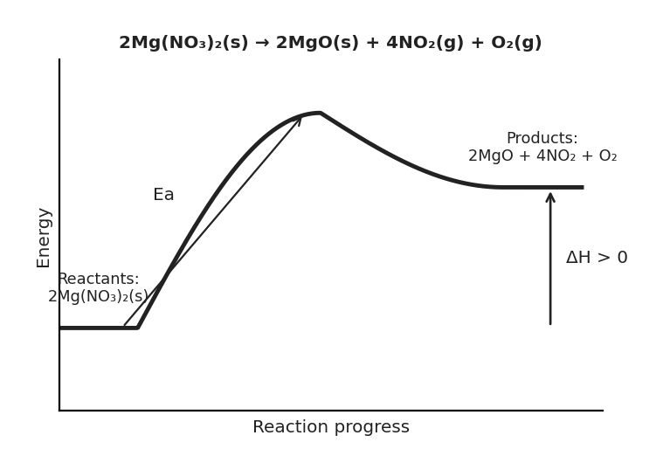
图 C₅-2：硝酸镁分解反应的能量-反应进程图（对应考点 C MCQ8，2Mg(NO₃)₂ → 2MgO + 4NO₂ + O₂，吸热）
A. Option A
B. Option B
C. Option C
D. Option D

9. In the reaction H₂ (g) + Cl₂ (g) → 2HCl (g) how many moles of which chemicals will remain when 1.5 moles of chlorine reacts with 2.0 moles of hydrogen? （ ）
A. Option A
B. 1.5 mol of HCl and 0.5 mol of H₂
C. 2.0 mol of HCl and 0.5 mol of Cl₂
D. 3.0 mol of HCl and 0.5 mol of H₂

10. Sodium reacts with water in the equation below. 2Na (s) + 2H₂O (l) → 2NaOH (aq) + H₂ (g) Which mass of sodium reacts with water to produce 960 mL of hydrogen gas at 1 atm and 20 oC? （ ）
A. Option A
B. Option B
C. Option C
D. Option D

11. 2N₂​O (g) → 2N₂ (g) + O₂ (g) At 600 oC, nitrous oxide decomposes according to the reaction represented above.
The reaction is completed at a constant temperature of 800 K in a rigid vessel.
The N₂O (g) is initially present in the vessel at a pressure of 1.50 atm.
What is the final pressure in the vessel after the reaction is complete? （ ）
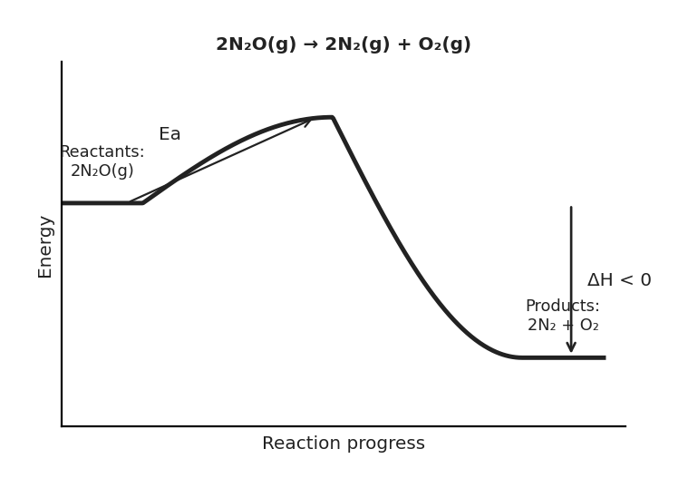
图 C₅-3：一氧化二氮分解反应的能量-反应进程图（对应考点 C MCQ11，2N₂O → 2N₂ + O₂，放热）
A. Diagram A — particle arrangement
B. Diagram B — particle arrangement
C. Diagram C — particle arrangement
D. Diagram D — particle arrangement

12. In a reaction vessel, 4.00 g of hydrogen gas reacts completely with excess oxygen gas to produce water vapor at 100 °C and 1.00 atm.
What volume of water vapor is produced under these conditions? (Use R = 0.0821 L atm mol−1 K−1) （ ）
A. Diagram A — particle arrangement
B. Diagram B — particle arrangement
C. Diagram C — particle arrangement
D. Diagram D — particle arrangement

13. Ammonia gas reacts with oxygen gas to produce nitrogen monoxide and water vapor.
If 10.0 L of ammonia gas reacts with 12.0 L of oxygen gas at the same temperature and pressure, what volume of nitrogen monoxide is produced? (Assume all gases are ideal.) （ ）
A. Option A
B. Option B
C. Option C
D. Option D

考点 D: 成分分析 Composition Analysis
1. 掌握经验式和分子式的计算
Empirical formula (经验式): simplest whole-number ratio of atoms
Combustion analysis: C → CO₂, H → H₂O; mass of O/N found by difference
Steps: mass → moles → divide by smallest → multiply to whole numbers

1. A 2.50 g sample containing only C, H, O is burned, producing 5.71 g CO₂ and 2.34 g H₂O.
(a) Calculate the mass of C and H in the sample. [2 marks]
(b) Calculate the mass of O in the sample. [1 mark]
(c) Determine the empirical formula. (C=12.01, H=1.008, O=16.00) [2 marks]

2. A compound of Mn and Cl is prepared.
Data: empty beaker = 60.169 g; beaker+Mn = 61.262 g; beaker+MnxCly = 62.673 g. (Mn=54.94, Cl=35.45)
(a) Calculate masses of Mn and Cl. [1 mark]
(b) Determine the empirical formula. [2 marks]

1. A scientist is examining a liquid mixture that contains water, ethanol, and dissolved sodium chloride.
The mixture appears uniform to the eye and shows identical properties when analyzed in various parts.
Which of the following statements best describes this sample? （ ）
A. The sample is a homogeneous mixture because the components are mixed at the molecular level and are uniformly distributed.
B. The sample is a heterogeneous mixture because the dissolved sodium chloride forms distinct phases in the solution.
C. The sample is a pure substance because the components combine chemically to form a new formula unit.
D. The sample consists of distinct microscopic regions of water and ethanol that do not fully intermix, making it non-uniform at the molecular level.

2. Which of the following correctly identifies the molecular arrangement in a heterogeneous mixture? （ ）
A. All particles are identical and evenly spaced.
B. Different types of particles are evenly mixed at the molecular level.
C. Different types of particles are grouped into distinct regions.
D. The particles are chemically bonded, forming uniform molecular structures.

3. A compound contains a compound 39% sulfur, 58.6 % oxygen and the remainder is hydrogen.
What is the empirical formula of the compound? （ ）
A. Option A
B. Option B
C. Option C
D. Option D

4. The chemical formula of the fertiliser ammonium nitrate is (NH₄NO₃).
What is the mass of nitrogen in 23.15 g sample of ammonium nitrate? （ ）
A. Option A
B. Option B
C. Option C
D. Option D

5. Which masses of carbon and hydrogen respectively would be the same as the mass of carbon and hydrogen in a pure sample of butene, C₄H₈? （ ）
A. Option A
B. Option B
C. Option C
D. Option D

6. Consider the chemical compound H₂S.
According to the Law of Definite Proportions, which of the following statements is true? （ ）
A. The mass ratio of hydrogen to sulfur in H₂S can vary depending on the source of the compound.
B. The mass ratio of hydrogen to sulfur in H₂S is always the same, regardless of the sample.
C. The mass ratio of hydrogen to sulfur in H₂S is determined by the reaction conditions used to produce the compound.
D. The Law of Definite Proportions does not apply to the compound H₂S.

7. A compound has the composition by mass: H, 5.00%; N, 35.00%; O, 60.00%.
Which compound has this composition? （ ）
A. Option A
B. Option B
C. Option C
D. Option D

8. A 6.2 g sample of a mixture containing magnesium chloride and sodium bromide is found to contain 0.45 g of magnesium.
Assuming no other sources of magnesium in the sample, what is the mass percent of MgCl₂ in the mixture? （ ）
A. Option A
B. Option B
C. Option C
D. Option D

9. A mixture of calcium carbonate and barium sulfate contains 30.0% of calcium carbonate.
If the mixture contains 1.20 g of calcium, what is the total mass of the mixture? （ ）
A. Option A
B. Option B
C. Option C
D. Option D

10. A 25.00 mL aliquot of hydrochloric acid was titrated with 0.225 M NaOH solution.
It took 36.20 mL of sodium hydroxide to neutralize the hydrochloric acid.
What was the molarity of the hydrochloric acid? （ ）
A. Option A⁻⁴ M
B. Option B⁻⁴ M
C. Option C
D. Option D

11. A sample of sodium hydroxide is dissolved in 250 mL of distilled water. 25.0 mL of this solution requires 15.0 mL of 2.00 M sulfuric acid to achieve complete neutralization. 2NaOH + H₂SO₄ → Na₂SO₄ + 2H₂O What is the mass of sodium hydroxide dissolved in 250 mL of distilled water? （ ）
A. Option A
B. Option B
C. Option C
D. Option D

12. 100 mL of a sodium carbonate solution, Na₂CO₃ (aq), of unknown concentration is reacted with excess calcium chloride solution, CaCl₂ (aq).
Na₂CO₃ (aq) + CaCl₂ (aq) → 2NaCl (aq) + CaCO₃ (s) The resulting calcium carbonate precipitate, CaCO₃ (s), is filtered and dried.
The following data is recorded.
Mass of filter paper0.77 gMass of filter paper + CaCO₃ precipitate1.94 g What is the molarity of the Na₂CO₃ (aq) solution? （ ）
A. Option A
B. Option B
C. Option C
D. Option D

13. A 50.00 mL sample of H₂SO₄ is titrated with 0.150 M NaOH.
It takes 45.00 mL of the sodium hydroxide solution to reach the equivalence point. H₂SO₄ + 2NaOH → Na₂SO₄ + 2H₂O What is the molarity of the H₂SO₄ solution? （ ）
A. Option A
B. Option B
C. Option C
D. Option D

